GENESIS FIELD THEORY (GenesisFT)

Working Model v1.3
A Unified Physical Formulation of the Genesis Field
This document provides the complete mathematical and conceptual foundation for Genesis Field Theory. It defines the physical field, governing equations, spectral structure, gravitational coupling, and predictions. Unlike the Overview—which explains the motivation and conceptual intuition—this Working Model establishes the formal physics structure of the theory.
EMPIRICAL STATUS UPDATE (2026-07-04). The cosmological P(k) derivation listed under Future Extensions (Section 8) has since been carried out via the GenesisFT–CAMB pipeline and tested against the Planck 2018 binned TT spectrum. Result: the kernel-vacuum Model A implementation is excluded wherever the operator spectrum measurably influences the primordial spectrum (coupling bound c ≲ 0.047 at a₂ = 8000); the configuration that matches Planck is the decoupling limit, identical to ΛCDM by construction. Any GenesisFT imprint on Pζ(k) must be ≲ 0.6% rms. The galaxy-scale predictions of Section 7 (cored halos, oscillatory rotation-curve features, lensing cores) are unaffected by this bound and remain open. Separately, the verified lensing-consistent MID-band eigenmode differs from the UCP template by relative L2 ≈ 0.72 — realistic halos are UV/MID/IR composites. Full analysis and replication instructions: the reproducibility folder of this repository (reproducibility/docs/GenesisFT_ModelA_Planck2018_TT_Validation_Report.docx).

1. Ontology — What Exists in GenesisFT?
GenesisFT postulates a single fundamental real scalar field Φ(x, t) defined in 3+1 dimensional spacetime. This field is the carrier of structure, stability, and dark-matter-like behavior in the universe. The field possesses an internal spectral organization into IR, MID, and UV stability bands, corresponding to large-scale structure, dark matter behavior, and fine-scale microstructure respectively.

Figure 1 — Spectral Band Structure
Below is the conceptual frequency band layout for Φ(x,t):
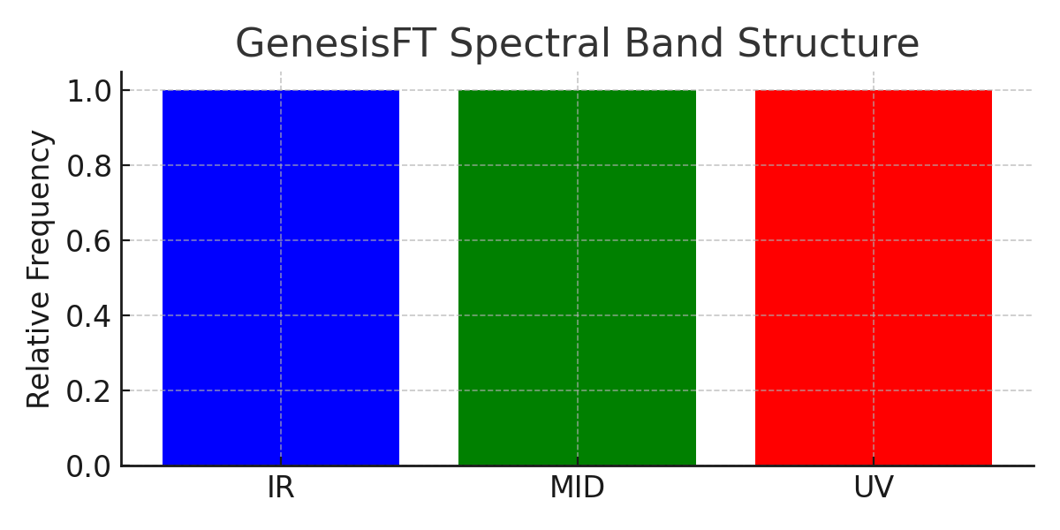

2. The Operator Ô and Spectral Bands
The spatial operator Ô defines the structural spectrum of the Genesis Field. It is expressed as:
(1) Ô = -∇² + V_eff(x)
Its eigenmodes satisfy:
(2) Ô χₙ(x) = λₙ χₙ(x)
These eigenmodes naturally fall into stability bands. The field Φ(x,t) decomposes as:
(3) Φ(x, t) = Σ aₙ(t) χₙ(x)

Figure 2 — Mode Decomposition of Φ(x,t)
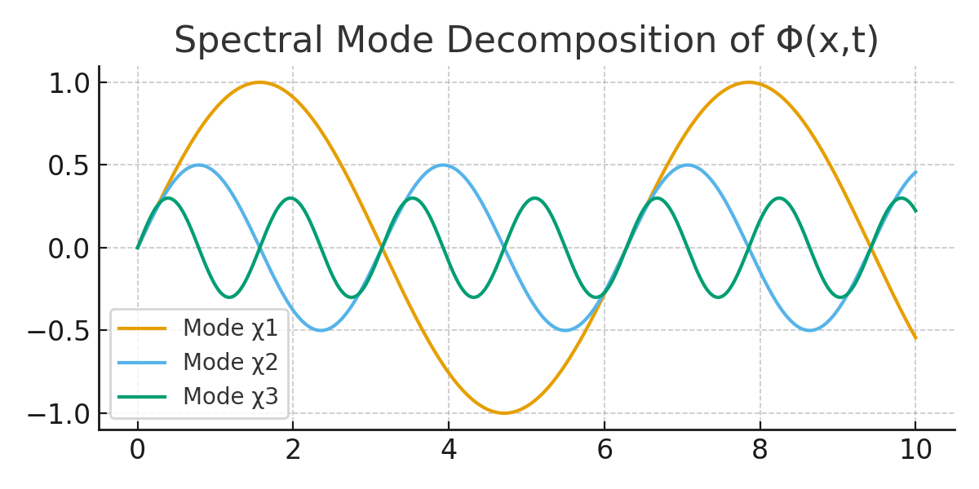
Each mode represents a stable vibrational pattern of the Genesis Field.

3. The Lagrangian — Core Physical Law
The complete dynamics of the Genesis Field are governed by the Lagrangian density:
(4) L = 1/2 (∂_μΦ ∂^μΦ) − 1/2 m²Φ² − 1/2 Φ Ô Φ − V(Φ)
This unifies:
• classical wave propagation
• an intrinsic mass scale
• the spectral geometry encoded in Ô
• optional self-interactions through V(Φ)
This Lagrangian is the mathematical heart of GenesisFT.

4. Equations of Motion
Applying the Euler–Lagrange equation yields the Genesis Field Equation:
(5) ∂²Φ/∂t² − ∇²Φ + m²Φ + ÔΦ + dV/dΦ = 0
Interpretation:
• The first two terms describe standard wave propagation.
• m²Φ provides harmonic restoring behavior.
• ÔΦ introduces the spectral band structure.
• dV/dΦ describes self-interaction.

5. Coupling to Gravity
Φ interacts gravitationally through the stress-energy tensor:
(6) T_{μν} = ∂_μΦ ∂_νΦ − g_{μν} L
In the Newtonian limit applicable to galaxies, gravity obeys:
(7) ∇²Φ_grav = 4πG ρ_eff
where ρ_eff is dominated by MID-band contributions that behave as dark matter.

Figure 3 — Cored Halo Density Profile
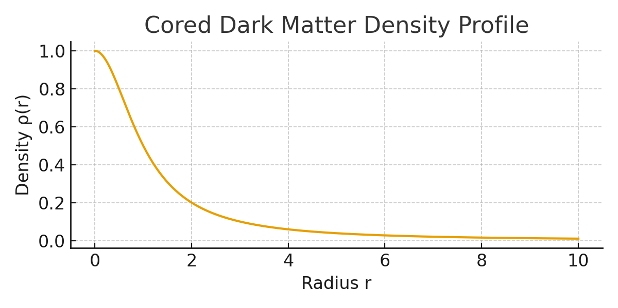
Wave pressure in the MID band naturally produces cored halo structures.

6. Interpretation of Bands
• IR Band — large-scale, slowly varying modes; govern cosmic background smoothness.
• MID Band — intermediate modes; form stable standing-wave structures behaving as dark matter.
• UV Band — high-frequency modes; influence small-scale corrections and microstructure.

7. Predictions of the Working Model
From the GenesisFT field equation and spectral structure, the following predictions arise:
1. Cored galactic halos formed naturally by wave pressure.
2. Oscillatory rotation curve features due to mode interference.
3. Suppression of small-scale halo formation.
4. Lens profiles shaped by finite-density cores.
5. Scaling relations between halo mass and radius derived from eigenvalue quantization.

8. Future Extensions
Future developments include:
• Analytical solutions for static halo configurations.
• Derivation of GenesisFT cosmological power spectrum P(k).
• Extension to early-universe behavior and inflation-like regimes.
• Numerical N-body simulations using the Genesis Field Equation.

